Student Details

Student Name:Mohamed Farah

Admission Number: BSCCS/2024/31995
Course:Computer science
Unit Code: BIT4138
Unit Name: Advanced Cryptography
Lecturers’ Name: Michael Nyoro
Semester: Year IV SEM II

Project Details

Project Title: Secure File Encryption System

Selected Technologies: Python + SQLite

GitHub Link: https://github.com/Mohaaz1/cryptography-lab.git

Student Details 1
Student Name:Mohamed Farah 1
Admission Number: BSCCS/2024/31995 1
Project Details 1
Project Title: Secure File Encryption System 1
Selected Technologies: Python + SQLite 1
GitHub Link: https://github.com/Mohaaz1/cryptography-lab.git 1
WEEK 1 TASKS 3
Python and VS Code Installation 3
Cryptography Library Installation 3
OpenSSL Installation Verification 3
Python Encryption Script Execution 3
GitHub Repository Initialization 3
WEEK 2 TASKS 4
Caesar Cipher Implementation 4
Vigenère Cipher Encryption Process 4
Encryption and Decryption Output 4
User Input Validation Interface 4
Cipher Testing Results 4
WEEK 3 TASKS 5
LFSR Generator Implementation 5
Pseudorandom Sequence Output 5
Statistical Randomness Testing 5
RC4 Stream Cipher Simulation 5
Encryption Performance Results 5
WEEK 4 TASKS 6
AES Encryption Script 6
Key Generation Process 6
File Encryption Demonstration 6
Decryption Results 6
AES Performance Testing 6
RSA Key Pair Generation 7
Public Key Encryption Process 7
Private Key Decryption Results 7
Secure Message Transmission 7
RSA Testing and Validation 7

WEEK 1 TASKS

Python and VS Code Installation
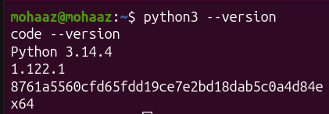
Figure i Python and VS Code Installation

Cryptography Library Installation
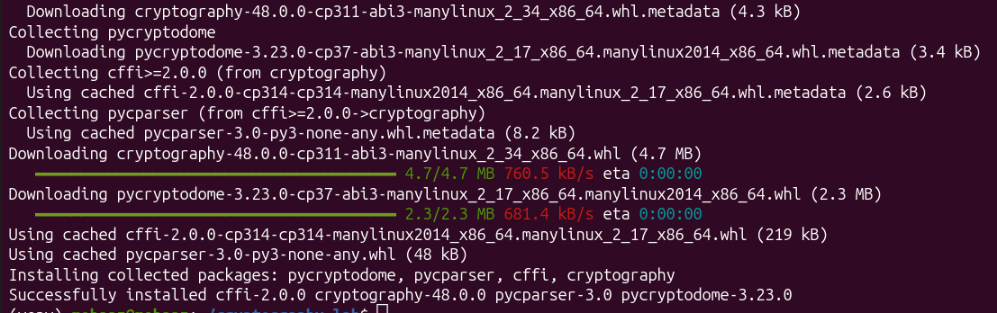
Figure ii Cryptography Library Installation

OpenSSL Installation Verification
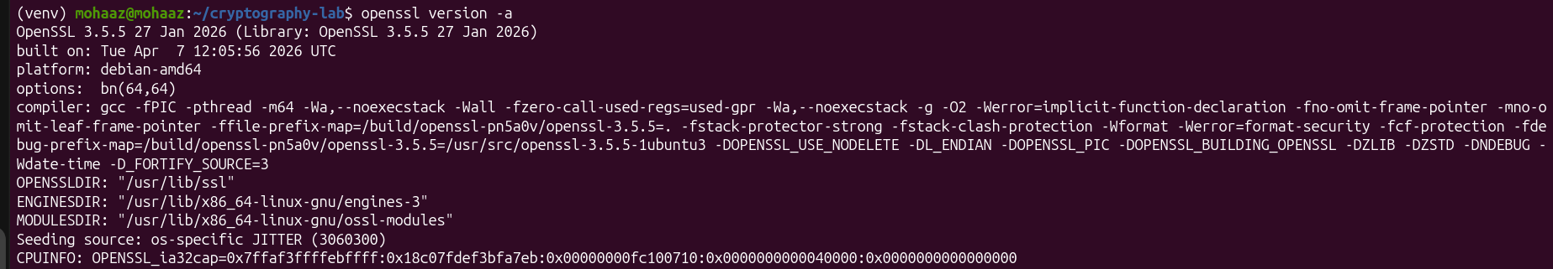
Figure iii OpenSSL Installation Verification

Python Encryption Script Execution
Figure iv Python Encryption Script Execution

GitHub Repository Initialization
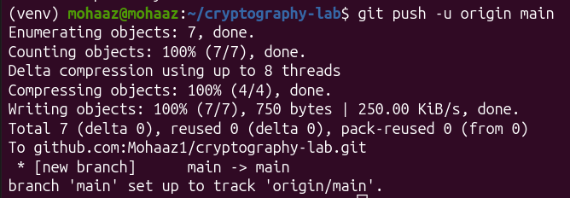
Figure v GitHub Repository Initialization
Setting up the development environment helped me understand how cryptographic tools are configured before any implementation begins. Configuring OpenSSL and initializing the GitHub repository gave me a solid foundation for the project ahead.

WEEK 2 TASKS

Caesar Cipher Implementation
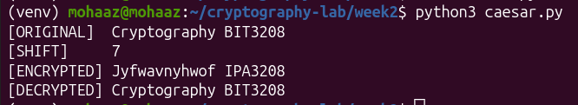
Figure vi Caesar Cipher Implementation

Vigenère Cipher Encryption Process
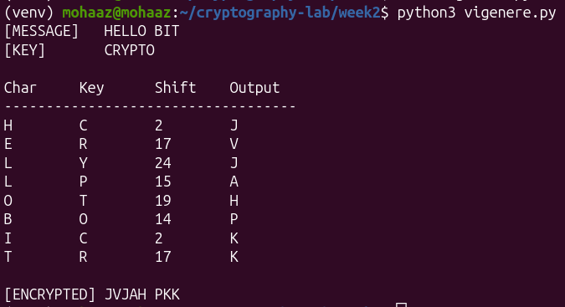
Figure vii Vigenère Cipher Encryption Process

Encryption and Decryption Output
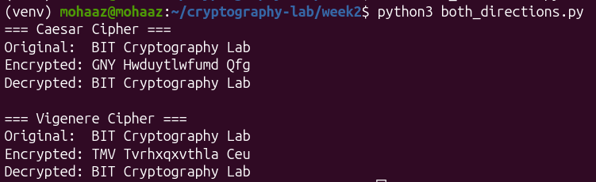
Figure viii Encryption and Decryption Output

User Input Validation Interface
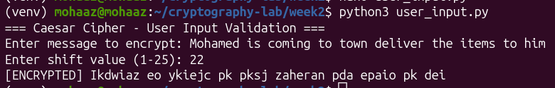
Figure ix User Input Validation Interface

Cipher Testing Results
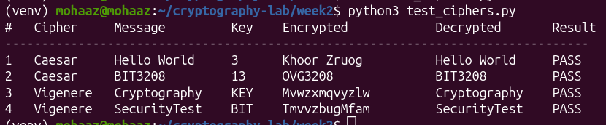
Figure x Cipher Testing Results
Implementing Caesar and Vigenère ciphers showed me how key length directly affects encryption strength. I also discovered how easily Caesar cipher can be broken through frequency analysis which highlighted the importance of more complex algorithms.
WEEK 3 TASKS

LFSR Generator Implementation
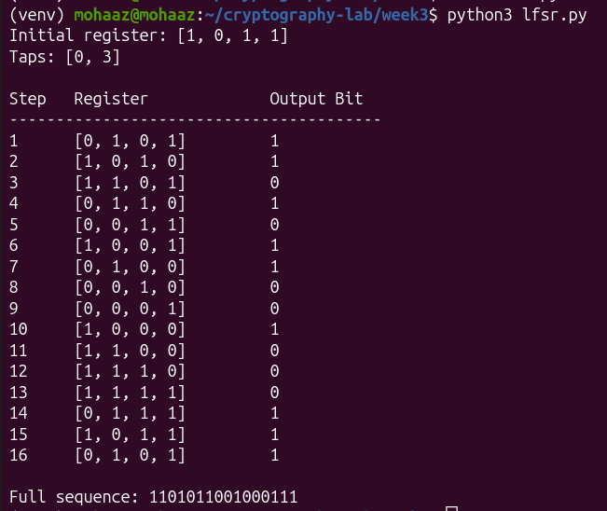
Figure xi : LFSR Generator Implementation

Pseudorandom Sequence Output
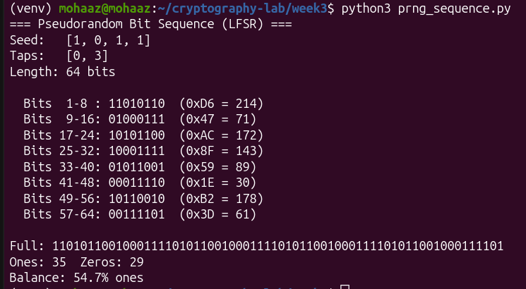
Figure xii Pseudorandom Sequence Output

Statistical Randomness Testing
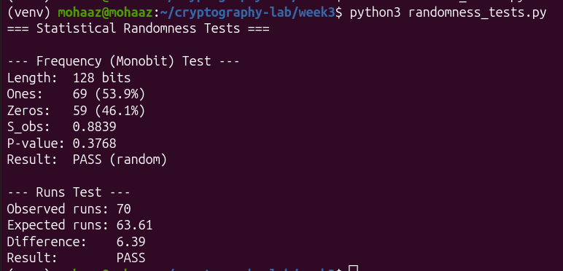
Figure xiii Statistical Randomness Testing

RC4 Stream Cipher Simulation
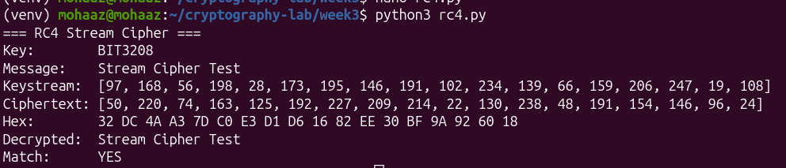
Figure xiv RC4 Stream Cipher Simulation

Encryption Performance Results
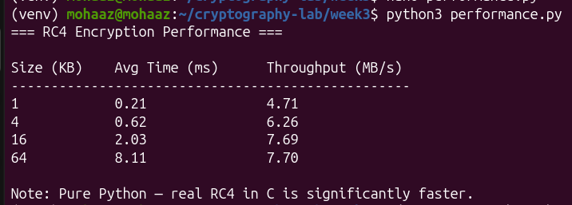
Figure xv Encryption Performance Results
Working with RC4 and the LFSR generator helped me understand how stream ciphers encrypt data continuously using a key-stream. I learned that weak seed values significantly reduce randomness quality, which can compromise the entire encryption process.
WEEK 4 TASKS

AES Encryption Script
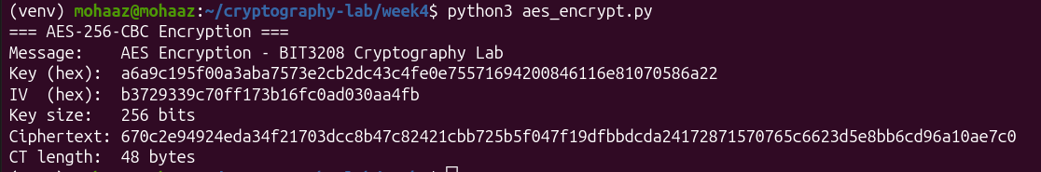
Figure xvi AES Encryption Script

Key Generation Process
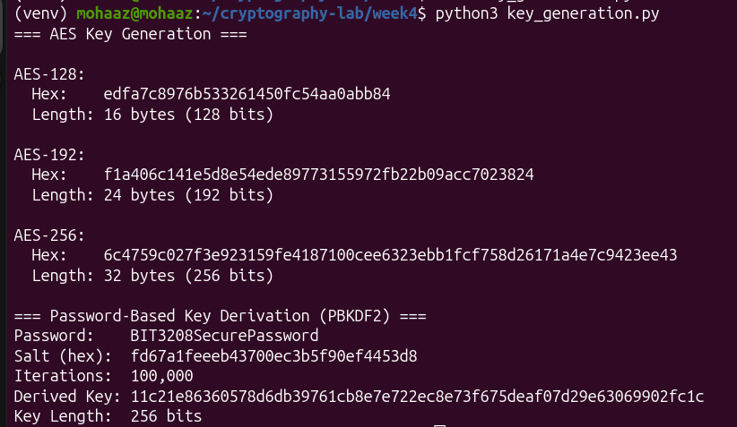
Figure xvii Key Generation Process

File Encryption Demonstration
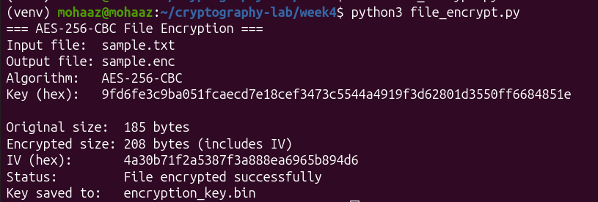
Figure xviii File Encryption Demonstration

Decryption Results
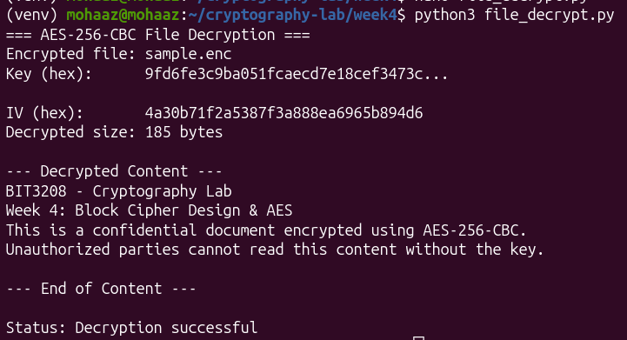
Figure xix Decryption Results

AES Performance Testing
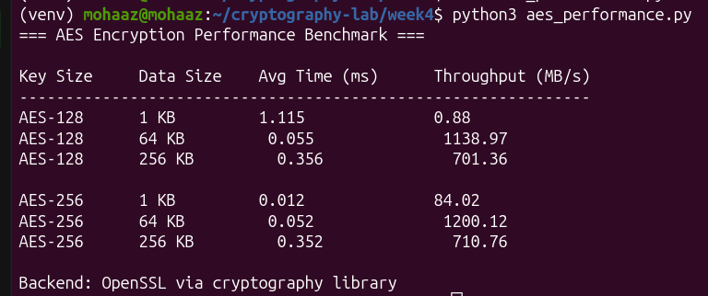
Figure xx AES Performance Testing
Implementing AES-256 demonstrated how block ciphers use fixed-size chunks and symmetric keys to achieve strong data protection. Managing the initialization vector correctly was the most challenging part, as any mismatch between encryption and decryption caused data corruption.
WEEK 5 TASKS

RSA Key Pair Generation
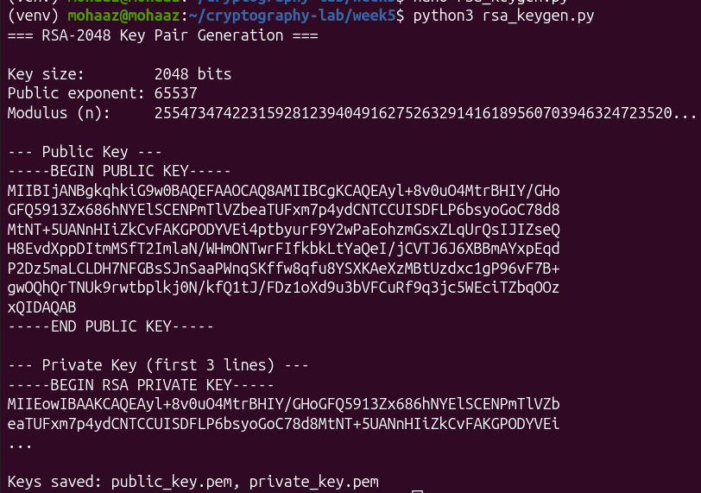
Figure xxi RSA Key Pair Generation

Public Key Encryption Process
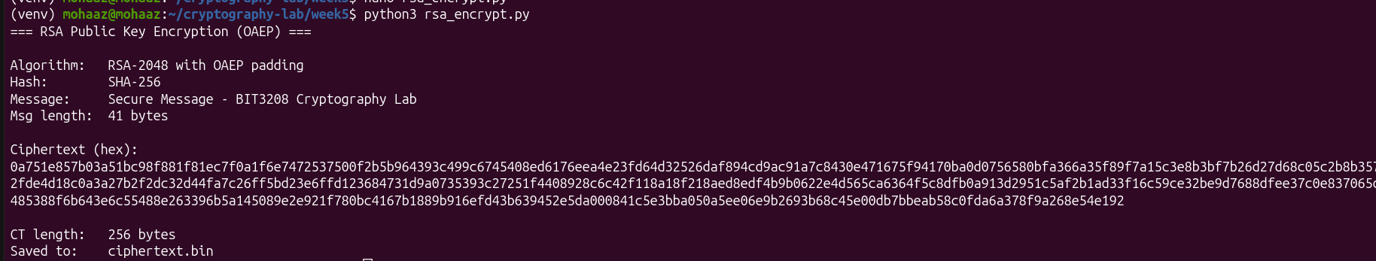
Figure xxii Public Key Encryption Process

Private Key Decryption Results
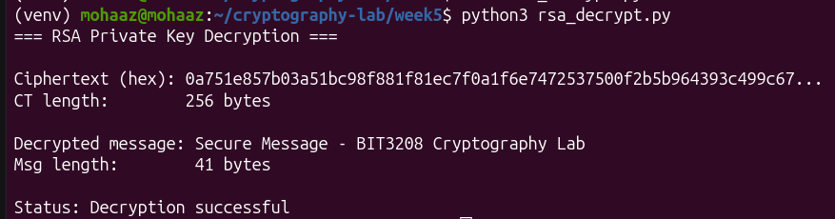
Figure xxiii Private Key Decryption Results

Secure Message Transmission
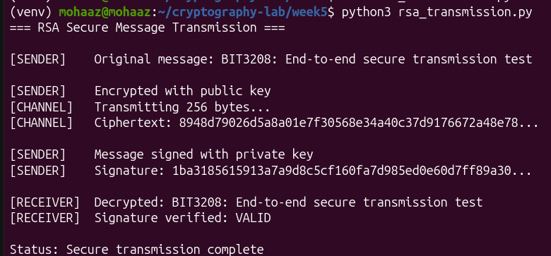
Figure xxiv Secure Message Transmission

RSA Testing and Validation
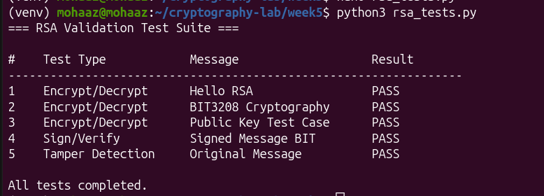
Figure xxv RSA Testing and Validation
RSA implementation showed me how asymmetric encryption eliminates the risk of sharing a secret key by using separate public and private keys. Handling key serialization and applying correct padding during encryption were the key technical challenges I overcame.

